17.84: Volume expansion: 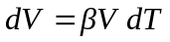
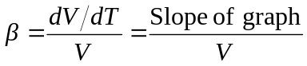
Construct the tangent to the graph at 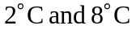 and measure the slope of this line.
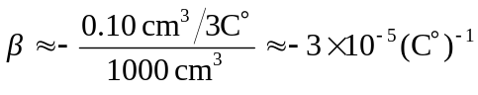
The slope in negative, as the water contracts or it is heated. At 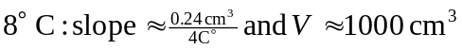
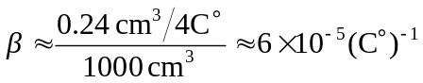
The water now expands when heated.

